SIMATS ENGINEERING (SAVEETHA SCHOOL OF ENGINEERING)
Department of Computer Science and Engineering
CO4 ASSESSMENT TOOL 1 – Test Case Design Assignment

Course Code: | CSA10 / CSA1063 | Course Title: | Software Engineering
CO Assessed: | CO4 | Assessment: | Assessment Tool 1 – Test Case Design Assignment
Weightage: | 20% | Total Marks: | 25
CO4 Statement: | Implement robust testing, quality assurance, and DevOps practices, emphasizing security, reliability, and ethics
Student Name: | MEGALA P | Reg. No.: | 192573019
Date: | 25/8/26 | Duration: | 60 minutes

Code of Conduct
I MEGALA P(192573019) (Name / Reg No) certify that this submission is my original work and that I have adhered to the guidelines specified for this assessment. I understand that any violation of academic integrity rules will result in disciplinary action.
Signature of the Student: MEGALA P
Annexure A – Test Case Design Assignment
Instructions to Students:
Each student is assigned an individual problem statement. Based on the assigned problem statement, design and document comprehensive test cases to verify the correctness, functionality, reliability, and usability of the proposed system.
Your test case design should include:
- Identify the functional and non-functional requirements to be tested.
- Identify the test scenarios for the assigned problem statement.
- Prepare detailed test cases covering normal, boundary, invalid, and exceptional conditions.
- Include Test Case ID, Test Scenario, Test Steps, Test Data, Expected Result, Actual Result, and Pass/Fail Status.
- Apply appropriate test design techniques such as Equivalence Partitioning, Boundary Value Analysis, Decision Table, or State Transition Testing wherever applicable.
- Ensure that the test cases provide adequate requirement and functional coverage for the assigned system.
Deliverable: Submit a Test Case Design document containing the identified scenarios, test cases, test data, expected results, and test coverage based on the individual problem statement.

Rubrics for Calculation
Evaluation Criteria | Excellent (4 Marks) | Good (3 Marks) | Satisfactory (2 Marks) | Needs Improvement (1 Mark)
Requirement & Test Scenario Identification(15%) | Clearly identifies all relevant functional/non-functional requirements and comprehensive test scenarios | Identifies most requirements and scenarios | Identifies basic requirements and scenarios | Requirements/scenarios are incomplete or unclear
Test Case Design & Completeness(25%) | Comprehensive test cases covering normal, boundary, invalid, and exceptional conditions | Covers most important conditions with minor gaps | Covers basic conditions but misses several important cases | Test cases are very limited or incomplete
Test Data & Expected Results(20%) | Appropriate test data with precise, measurable expected results for every test case | Mostly appropriate test data and expected results | Some test data/results are unclear or incomplete | Test data and expected results are largely missing/incorrect
Application of Test Design Techniques(15%) | Correctly applies multiple techniques such as Equivalence Partitioning, Boundary Value Analysis, Decision Table, and State Transition | Correctly applies at least two relevant techniques | Applies one technique with limited justification | Techniques are not applied or incorrectly applied
Traceability & Test Coverage(15%) | Excellent mapping between requirements, scenarios, and test cases with strong coverage | Good traceability and coverage with minor gaps | Partial traceability and moderate coverage | Poor/no traceability and inadequate coverage
Documentation & Presentation(10%) | Well-structured, clear, professional, consistent, and easy to understand | Well-organized with minor presentation issues | Adequately organized but has some clarity/formatting issues | Poorly organized, unclear, or incomplete documentation

Criteria | Mark
Requirement & Test Scenario Identification (15%) | /5
Test Case Design & Completeness (25%) | /4
Test Data & Expected Results (20%) | /4
Application of Test Design Techniques (15%) | /4
Traceability & Test Coverage (15%) | /4
Documentation & Presentation (10%) | /4
TOTAL | /25

CO4-ASSISSMENT TOOL-1

COURSE CODE: CSA1007
COURSE NAME: SOFTWARE ENGINEERING
NAME: P MEGALA
REG NO: 192573019

40) Factory Energy Monitoring and Machine Utilization Optimization System
Industry Context
The manufacturing sector is rapidly adopting digital technologies to improve efficiency, energy management, productivity, scalability, and decision making. Traditional approaches often rely on manual meter readings and reactive machine monitoring, resulting in energy wastage, increased operating costs, machine downtime, under-utilization of equipment, and reduced production efficiency. There is a growing need for an intelligent, cloud-enabled, distributed platform capable of collecting real-time IoT and enterprise data, analyzing operational conditions, predicting risks, and supporting timely interventions.
Problem Statement
Design and develop a distributed Factory Energy Monitoring and Machine Utilization Optimization System that continuously acquires real-time operational data from connected energy meters, sensors, PLCs, machines, enterprise systems, and users. The platform should detect abnormal energy consumption and machine utilization patterns, generate predictive insights using AI/ML, notify stakeholders in real time, provide centralized dashboards, generate reports, and support secure, scalable, fault-tolerant operation across multiple factory locations.
Objectives
Collect real-time operational data.
Monitor system performance continuously.
Detect anomalies automatically.
Predict failures or risks using analytics.
Notify stakeholders immediately.
Generate dashboards and reports.
Test Case Design Assignment
Project Title:
Factory Energy Monitoring and Machine Utilization Optimization System
1. Functional and Non-Functional Requirements
Functional Requirements:
ID | Requirement
FR01 | Collect real-time energy and machine data
FR02 | Monitor energy consumption and machine utilization
FR03 | Detect abnormal energy consumption
FR04 | Predict machine failures or energy/utilization risks
FR05 | Calculate machine utilization and idle time
FR06 | Send alerts to stakeholders
FR07 | Display energy and machine information on dashboard
FR08 | Generate energy and utilization reports
Non-Functional Requirements:
ID | Requirement
NFR01 | System should respond quickly
NFR02 | System should be reliable
NFR03 | System should provide secure access
NFR04 | System should support multiple factory locations
NFR05 | System should be easy to use
NFR06 | System should handle increasing energy and machine data

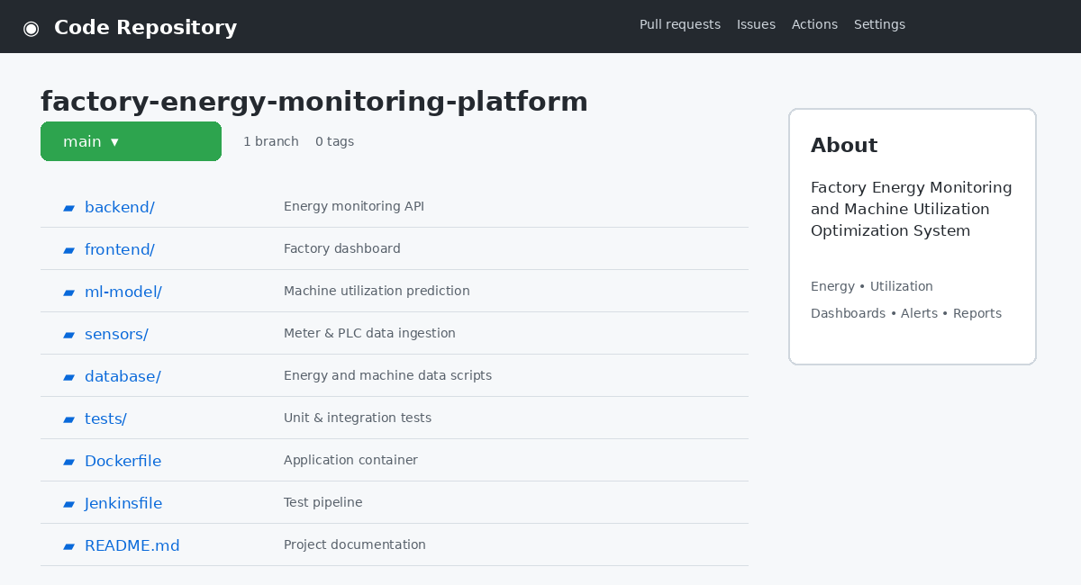

2. Test Scenarios
The following scenarios are identified for the factory energy and machine utilization platform:
Scenario ID | Test Scenario
TS01 | Verify energy and machine data collection
TS02 | Verify energy consumption monitoring
TS03 | Verify machine utilization monitoring
TS04 | Verify abnormal energy detection
TS05 | Verify machine under-utilization detection
TS06 | Verify predictive risk analysis
TS07 | Verify alert notification
TS08 | Verify dashboard display
TS09 | Verify report generation
TS10 | Verify invalid sensor data handling
TS11 | Verify system response during high data load
TS12 | Verify secure user access
TS13 | Verify system recovery after failure
TS14 | Verify no-data report handling

3. Detailed Test Cases
The test cases contain Test Case ID, Test Scenario, Test Steps, Test Data, Expected Result, Actual Result, and Pass/Fail Status.
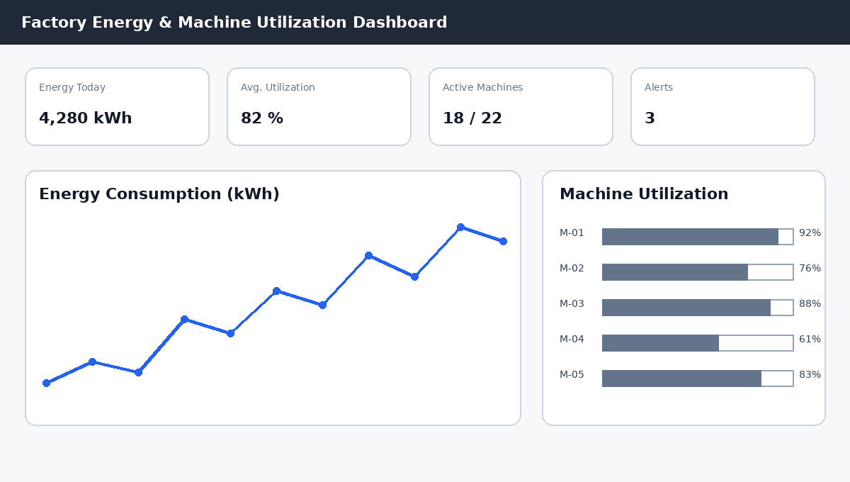

ID Test Scenario Test Steps Test Data Expected Result Actual Result Status
TC01
Energy data collection
Send valid meter reading
Energy = 125 kWh
Data should be collected successfully
Data collected
Pass
TC02
Energy monitoring
Open dashboard
Energy = 4,280 kWh
Current energy consumption should be displayed
Energy displayed
Pass
TC03
Machine utilization
Submit runtime and idle time
Runtime=7 hr, Idle=1 hr
Utilization should be 87.5%
87.5% displayed
Pass
TC04
Abnormal energy detection
Enter high energy value
Energy = 950 kWh
System should detect abnormal consumption
Abnormal condition detected
Pass
TC05
Under-utilization detection
Submit low runtime
Runtime=2 hr / Shift=8 hr
System should flag under-utilization
Under-utilization detected
Pass
TC06
Predictive risk analysis
Submit machine history
Vibration + downtime history
System should generate risk prediction
Risk predicted
Pass
TC07
Alert notification
Generate abnormal condition
Energy threshold exceeded
Alert should be sent
Alert generated
Pass
TC08
Dashboard display
Open dashboard
Current factory data
Data should be displayed correctly
Data displayed
Pass
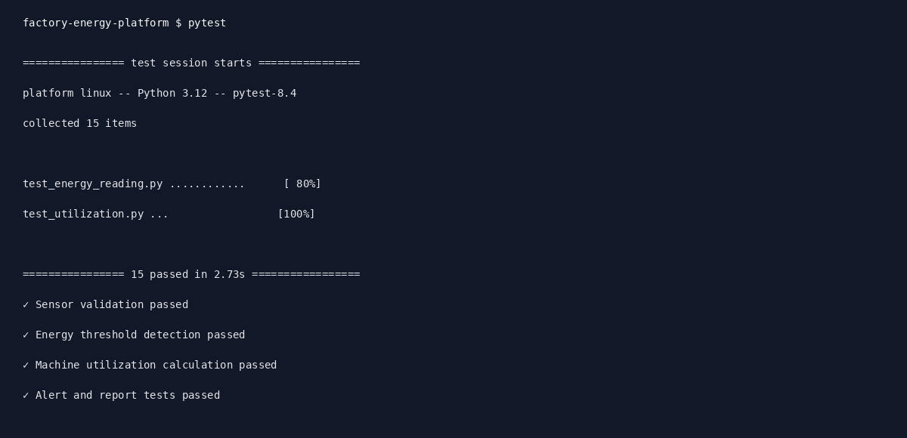

TC09
Report generation
Select report option
Daily energy + utilization
Report should be generated
Report generated
Pass
TC10
Invalid sensor data
Enter invalid reading
Energy = -50 kWh
System should reject invalid data
Invalid data rejected
Pass
TC11
Empty input
Submit without reading
Blank
Validation message should appear
Message displayed
Pass
TC12
User authentication
Enter valid login details
Valid username/password
User should be logged in
Login successful
Pass
TC13
Invalid login
Enter incorrect credentials
Wrong password
Access should be denied
Access denied
Pass
TC14
High data load
Send large data set
10,000 sensor records
System should continue processing
Data processed
Pass
TC15
Database failure
Disconnect database
Database unavailable
System should show appropriate error
Error displayed
Pass
TC16
Report with no data
Request report without records
Empty dataset
System should show no-data message
Message displayed
Pass
4. Test Design Techniques
The assignment requires suitable techniques such as Equivalence Partitioning, Boundary Value Analysis, Decision Table, and State Transition Testing.
Equivalence Partitioning:
Energy readings and machine utilization inputs can be divided into valid and invalid groups.
Input Class | Example | Classification
Energy ≥ 0 | 125 kWh | Valid
Negative energy | -50 kWh | Invalid
Numeric text | ABC | Invalid
Utilization 0–100% | 82% | Valid
Utilization >100% | 125% | Invalid
Example:
125 kWh → Valid
Boundary Value Analysis:
For energy reading:
-1 → Invalid
0 → Valid
1 → Valid
For machine utilization:
-1% → Invalid
0% → Valid
100% → Valid
101% → Invalid
This verifies the system near important input boundaries.
Decision Table:
For abnormal energy and machine utilization:
Energy Level | Utilization | Abnormal Condition | System Action
Normal | High | No | Continue monitoring
Normal | Low | Yes | Flag under-utilization
High | High | Yes | Generate energy alert
High | Low | Yes | Generate alert + maintenance recommendation
State Transition Testing
Machine monitoring states can be:
Normal → Warning → Critical → Maintenance → Normal
Example transitions:
Normal → Warning when energy crosses the warning threshold.
Warning → Critical when abnormal energy or machine risk becomes severe.
Critical → Maintenance when intervention is required.
Maintenance → Normal after the machine is restored and validated.
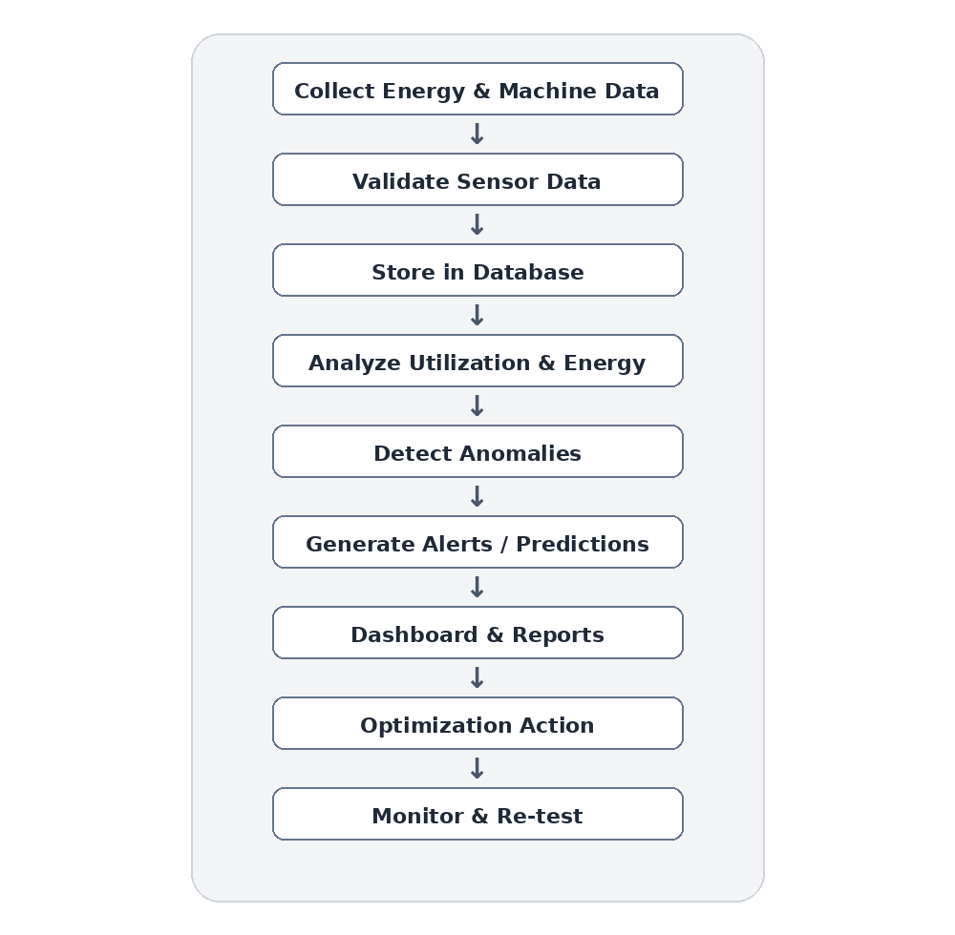
5. Traceability and Test Coverage:
The test cases are mapped to the functional and non-functional requirements.
Requirement | Test Cases | Coverage
FR01 Data Collection | TC01 | Covered
FR02 Monitoring | TC02, TC03 | Covered
FR03 Anomaly Detection | TC04, TC05 | Covered
FR04 Prediction | TC06 | Covered
FR05 Utilization Calculation | TC03, TC05 | Covered
FR06 Alerts | TC07 | Covered
FR07 Dashboard | TC08 | Covered
FR08 Reports | TC09, TC16 | Covered
NFR01 Performance | TC14 | Covered
NFR03 Security | TC12, TC13 | Covered
NFR02 Reliability | TC15 | Covered
NFR06 Scalability | TC14 | Covered
This provides traceability between requirements → test scenarios → test cases. The rubric gives importance to strong requirement and test coverage.
6. Development, Testing and Production Environments
Development Environment
Developers create and modify energy monitoring, machine utilization, dashboard, and analytics features here.
Developer → Git → Development
Testing/Staging Environment
The complete application is tested with simulated or controlled energy and machine data before release.
Development → Automated Tests → Staging
Production Environment
The final tested system is deployed for factory operations, maintenance teams, production users, and energy managers.
Staging → Approval → Production
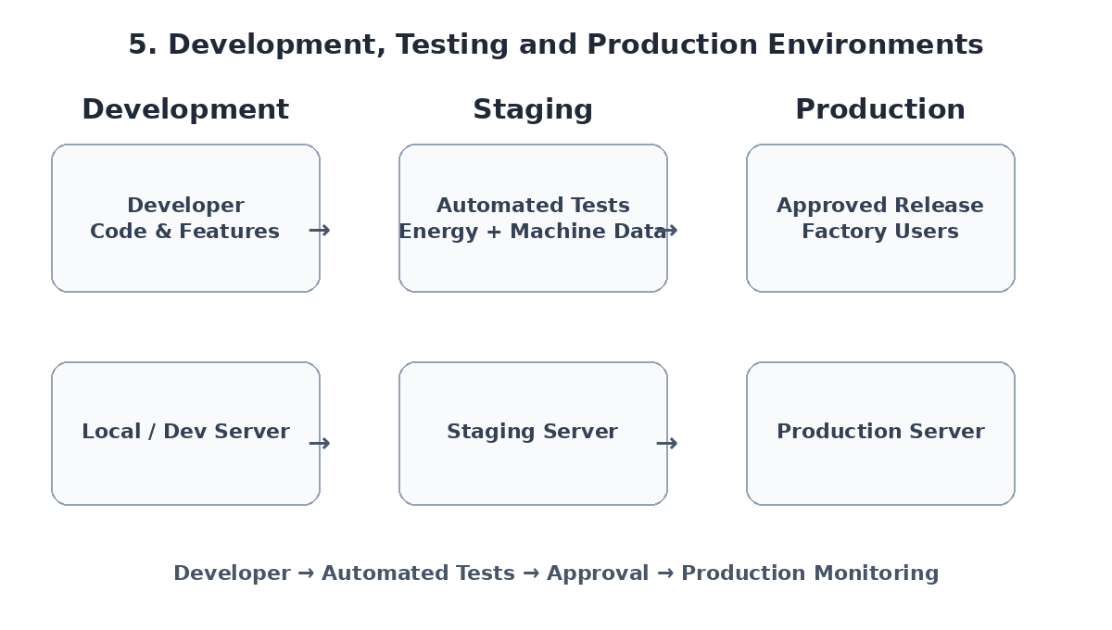
7. Test Case Summary:
Normal conditions – TC01–TC09
Boundary conditions – Boundary Value Analysis
Invalid conditions – TC10, TC11, TC13
Exceptional conditions – TC14, TC15, TC16
Therefore, the test cases cover the major functional and non-functional requirements of the Factory Energy Monitoring and Machine Utilization Optimization System.
8. Final System Flowchart / Architecture
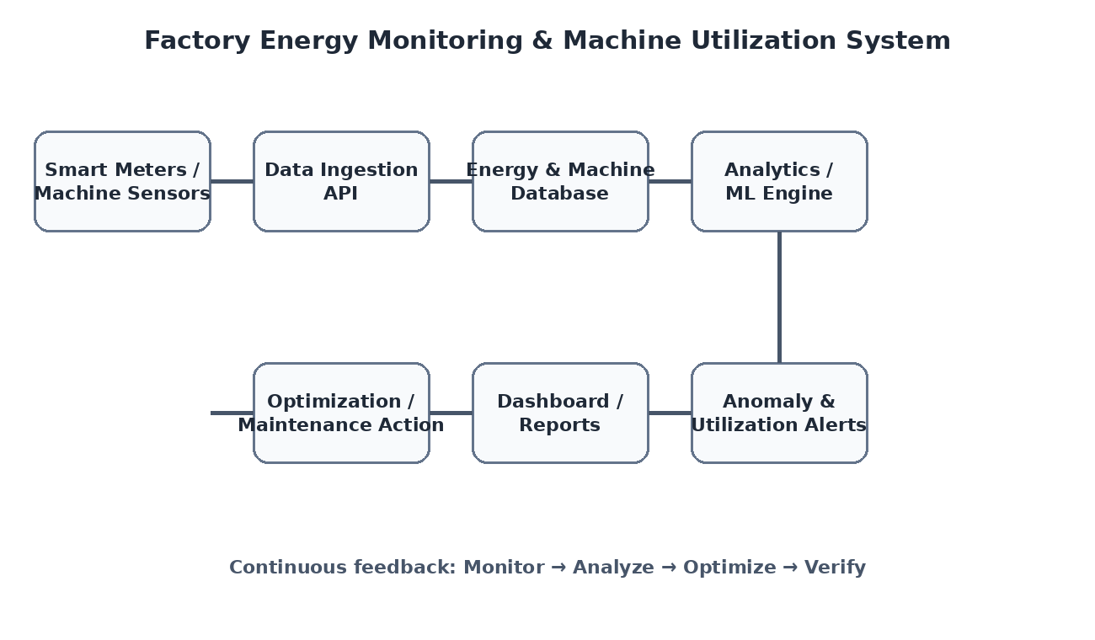
9. Test Case Document Conclusion:
The designed test cases verify the correctness, functionality, reliability, security, performance, and usability of the Factory Energy Monitoring and Machine Utilization Optimization System. The test cases cover normal, boundary, invalid, and exceptional conditions. Different test design techniques are applied to improve the quality and coverage of testing.
The test case document therefore provides systematic validation of the proposed system and helps identify defects before deployment. The included factory dashboard, repository, automated test, environment, workflow, and architecture visuals provide clear representation of the system and its testing process.
The document maintains the organization and assessment structure of the provided reference while replacing the traffic-specific requirements, scenarios, test cases, techniques, traceability, and visuals with content relevant to factory energy monitoring and machine utilization optimization.

